雅居苑教师公寓公租房项目房型及租金一览

本次出租房源共120套，分别为一号楼2、3、4、5、6、7、8、10、12、13、14、15、16、17、18等楼层。每楼层套型和布局均为一致。现把套内面积和计划租金公示如下：
序号 | 房号 | 建筑面积  （㎡） | 套内面积  （㎡） | 每月租金评估 |  | 计划物业管理费用（每平方1.1元） | 每月实际租金
 |  |  |  | 月租金单价 （元/㎡） | 月租金（元） | 计划物业管理费用（每平方1.1元） | 评估值（元）
1 | 201 | 76.9 | 62.46 | 8 | 615.2 | 84.59 | 700
2 | 202 | 73.97 | 60.08 | 8 | 591.76 | 81.367 | 673
3 | 203 | 72.68 | 59.03 | 7.5 | 545.1 | 79.948 | 625
4 | 204 | 74.14 | 60.21 | 7.5 | 556.05 | 81.554 | 638
5 | 205 | 37.58 | 30.52 | 8 | 300.64 | 41.338 | 342
6 | 206 | 37.58 | 30.52 | 8 | 300.64 | 41.338 | 342
7 | 207 | 75.08 | 60.98 | 7.5 | 563.1 | 82.588 | 646
8 | 208 | 47.02 | 38.19 | 8 | 376.16 | 51.722 | 428
9 | 301 | 76.90 | 62.46 | 8 | 615.2 | 84.59 | 700
10 | 302 | 73.97 | 60.08 | 8 | 591.76 | 81.367 | 673
11 | 303 | 72.68 | 59.03 | 7.5 | 545.1 | 79.948 | 625
12 | 304 | 74.14 | 60.21 | 7.5 | 556.05 | 81.554 | 638
13 | 305 | 37.58 | 30.52 | 8 | 300.64 | 41.338 | 342
14 | 306 | 37.58 | 30.52 | 8 | 300.64 | 41.338 | 342
15 | 307 | 75.08 | 60.98 | 7.5 | 563.1 | 82.588 | 646
16 | 308 | 47.02 | 38.19 | 8 | 376.16 | 51.722 | 428
17 | 401 | 76.9 | 62.46 | 8 | 615.2 | 84.59 | 700
18 | 402 | 73.97 | 60.08 | 8 | 591.76 | 81.367 | 673
19 | 403 | 72.68 | 59.03 | 7.5 | 545.1 | 79.948 | 625
20 | 404 | 74.14 | 60.21 | 7.5 | 556.05 | 81.554 | 638
21 | 405 | 37.58 | 30.52 | 8 | 300.64 | 41.338 | 342
22 | 406 | 37.58 | 30.52 | 8 | 300.64 | 41.338 | 342
23 | 407 | 75.08 | 60.98 | 7.5 | 563.1 | 82.588 | 646
24 | 408 | 47.02 | 38.19 | 8 | 376.16 | 51.722 | 428
25 | 501 | 76.9 | 62.46 | 8.5 | 653.65 | 84.59 | 738
26 | 502 | 73.97 | 60.08 | 8.5 | 628.745 | 81.367 | 710
27 | 503 | 72.68 | 59.03 | 8 | 581.44 | 79.948 | 661
28 | 504 | 74.14 | 60.21 | 8 | 593.12 | 81.554 | 675
29 | 505 | 37.58 | 30.52 | 8.5 | 319.43 | 41.338 | 361
30 | 506 | 37.58 | 30.52 | 8.5 | 319.43 | 41.338 | 361
31 | 507 | 75.08 | 60.98 | 8 | 600.64 | 82.588 | 683
32 | 508 | 47.02 | 38.19 | 8.5 | 399.67 | 51.722 | 451
33 | 601 | 76.9 | 62.46 | 8.5 | 653.65 | 84.59 | 738
34 | 602 | 73.97 | 60.08 | 8.5 | 628.745 | 81.367 | 710
35 | 603 | 72.68 | 59.03 | 8 | 581.44 | 79.948 | 661
36 | 604 | 74.14 | 60.21 | 8 | 593.12 | 81.554 | 675
37 | 605 | 37.58 | 30.52 | 8.5 | 319.43 | 41.338 | 361
38 | 606 | 37.58 | 30.52 | 8.5 | 319.43 | 41.338 | 361
39 | 607 | 75.08 | 60.98 | 8 | 600.64 | 82.588 | 683
40 | 608 | 47.02 | 38.19 | 8.5 | 399.67 | 51.722 | 451
41 | 701 | 76.9 | 62.46 | 8.5 | 653.65 | 84.59 | 738
42 | 702 | 73.97 | 60.08 | 8.5 | 628.745 | 81.367 | 710
43 | 703 | 72.68 | 59.03 | 8 | 581.44 | 79.948 | 661
44 | 704 | 74.14 | 60.21 | 8 | 593.12 | 81.554 | 675
45 | 705 | 37.58 | 30.52 | 8.5 | 319.43 | 41.338 | 361
46 | 706 | 37.58 | 30.52 | 8.5 | 319.43 | 41.338 | 361
47 | 707 | 75.08 | 60.98 | 8 | 600.64 | 82.588 | 683
48 | 708 | 47.02 | 38.19 | 8.5 | 399.67 | 51.722 | 451
49 | 801 | 76.9 | 62.46 | 9 | 692.1 | 84.59 | 777
50 | 802 | 73.97 | 60.08 | 9 | 665.73 | 81.367 | 747
51 | 803 | 72.68 | 59.03 | 8.5 | 617.78 | 79.948 | 698
52 | 804 | 74.14 | 60.21 | 8.5 | 630.19 | 81.554 | 712
53 | 805 | 37.58 | 30.52 | 9 | 338.22 | 41.338 | 380
54 | 806 | 37.58 | 30.52 | 9 | 338.22 | 41.338 | 380
55 | 807 | 75.08 | 60.98 | 8.5 | 638.18 | 82.588 | 721
56 | 808 | 47.02 | 38.19 | 9 | 423.18 | 51.722 | 475
65 | 1001 | 76.9 | 62.46 | 9 | 692.1 | 84.59 | 777
66 | 1002 | 73.97 | 60.08 | 9 | 665.73 | 81.367 | 747
67 | 1003 | 72.68 | 59.03 | 8.5 | 617.78 | 79.948 | 698
68 | 1004 | 74.14 | 60.21 | 8.5 | 630.19 | 81.554 | 712
69 | 1005 | 37.58 | 30.52 | 9 | 338.22 | 41.338 | 380
70 | 1006 | 37.58 | 30.52 | 9 | 338.22 | 41.338 | 380
71 | 1007 | 75.08 | 60.98 | 8.5 | 638.18 | 82.588 | 721
72 | 1008 | 47.02 | 38.19 | 9 | 423.18 | 51.722 | 475
81 | 1201 | 76.9 | 62.46 | 9.5 | 730.55 | 84.59 | 815
82 | 1202 | 73.97 | 60.08 | 9.5 | 702.715 | 81.367 | 784
83 | 1203 | 72.68 | 59.03 | 9 | 654.12 | 79.948 | 734
84 | 1204 | 74.14 | 60.21 | 9 | 667.26 | 81.554 | 749
85 | 1205 | 37.58 | 30.52 | 9.5 | 357.01 | 41.338 | 398
86 | 1206 | 37.58 | 30.52 | 9.5 | 357.01 | 41.338 | 398
87 | 1207 | 75.08 | 60.98 | 9 | 675.72 | 82.588 | 758
88 | 1208 | 47.02 | 38.19 | 9.5 | 446.69 | 51.722 | 498
89 | 1301 | 76.9 | 62.46 | 9.5 | 730.55 | 84.59 | 815
90 | 1302 | 73.97 | 60.08 | 9.5 | 702.715 | 81.367 | 784
91 | 1303 | 72.68 | 59.03 | 9 | 654.12 | 79.948 | 734
92 | 1304 | 74.14 | 60.21 | 9 | 667.26 | 81.554 | 749
93 | 1305 | 37.58 | 30.52 | 9.5 | 357.01 | 41.338 | 398
94 | 1306 | 37.58 | 30.52 | 9.5 | 357.01 | 41.338 | 398
95 | 1307 | 75.08 | 60.98 | 9 | 675.72 | 82.588 | 758
96 | 1308 | 47.02 | 38.19 | 9.5 | 446.69 | 51.722 | 498
97 | 1401 | 76.9 | 62.46 | 10 | 769 | 84.59 | 854
98 | 1402 | 73.97 | 60.08 | 10 | 739.7 | 81.367 | 821
99 | 1403 | 72.68 | 59.03 | 9.5 | 690.46 | 79.948 | 770
100 | 1404 | 74.14 | 60.21 | 9.5 | 704.33 | 81.554 | 786
101 | 1405 | 37.58 | 30.52 | 10 | 375.8 | 41.338 | 417
102 | 1406 | 37.58 | 30.52 | 10 | 375.8 | 41.338 | 417
103 | 1407 | 75.08 | 60.98 | 9.5 | 713.26 | 82.588 | 796
104 | 1408 | 47.02 | 38.19 | 10 | 470.2 | 51.722 | 522
105 | 1501 | 76.9 | 62.46 | 10 | 769 | 84.59 | 854
106 | 1502 | 73.97 | 60.08 | 10 | 739.7 | 81.367 | 821
107 | 1503 | 72.68 | 59.03 | 9.5 | 690.46 | 79.948 | 770
108 | 1504 | 74.14 | 60.21 | 9.5 | 704.33 | 81.554 | 786
109 | 1505 | 37.58 | 30.52 | 10 | 375.8 | 41.338 | 417
110 | 1506 | 37.58 | 30.52 | 10 | 375.8 | 41.338 | 417
111 | 1507 | 75.08 | 60.98 | 9.5 | 713.26 | 82.588 | 796
112 | 1508 | 47.02 | 38.19 | 10 | 470.2 | 51.722 | 522
113 | 1601 | 76.9 | 62.46 | 10 | 769 | 84.59 | 854
114 | 1602 | 73.97 | 60.08 | 10 | 739.7 | 81.367 | 821
115 | 1603 | 72.68 | 59.03 | 9.5 | 690.46 | 79.948 | 770
116 | 1604 | 74.14 | 60.21 | 9.5 | 704.33 | 81.554 | 786
117 | 1605 | 37.58 | 30.52 | 10 | 375.8 | 41.338 | 417
118 | 1606 | 37.58 | 30.52 | 10 | 375.8 | 41.338 | 417
119 | 1607 | 75.08 | 60.98 | 9.5 | 713.26 | 82.588 | 796
120 | 1608 | 47.02 | 38.19 | 9 | 423.18 | 51.722 | 475
121 | 1701 | 76.9 | 62.46 | 9.5 | 730.55 | 84.59 | 815
122 | 1702 | 73.97 | 60.08 | 9.5 | 702.715 | 81.367 | 784
123 | 1703 | 72.68 | 59.03 | 9 | 654.12 | 79.948 | 734
124 | 1704 | 74.14 | 60.21 | 9 | 667.26 | 81.554 | 749
125 | 1705 | 37.58 | 30.52 | 9.5 | 357.01 | 41.338 | 398
126 | 1706 | 37.58 | 30.52 | 9.5 | 357.01 | 41.338 | 398
127 | 1707 | 75.08 | 60.98 | 9 | 675.72 | 82.588 | 758
128 | 1708 | 47.02 | 38.19 | 9.5 | 446.69 | 51.722 | 498
129 | 1801 | 76.9 | 62.46 | 9.5 | 730.55 | 84.59 | 815
130 | 1802 | 73.97 | 60.08 | 9.5 | 702.715 | 81.367 | 784
131 | 1803 | 72.68 | 59.03 | 9 | 654.12 | 79.948 | 734
132 | 1804 | 74.14 | 60.21 | 9 | 667.26 | 81.554 | 749
133 | 1805 | 37.58 | 30.52 | 9.5 | 357.01 | 41.338 | 398
134 | 1806 | 37.58 | 30.52 | 9.5 | 357.01 | 41.338 | 398
135 | 1807 | 75.08 | 60.98 | 9 | 675.72 | 82.588 | 758
136 | 1808 | 47.02 | 38.19 | 9.5 | 446.69 | 51.722 | 498

雅居苑教师公寓公租房项目户型图

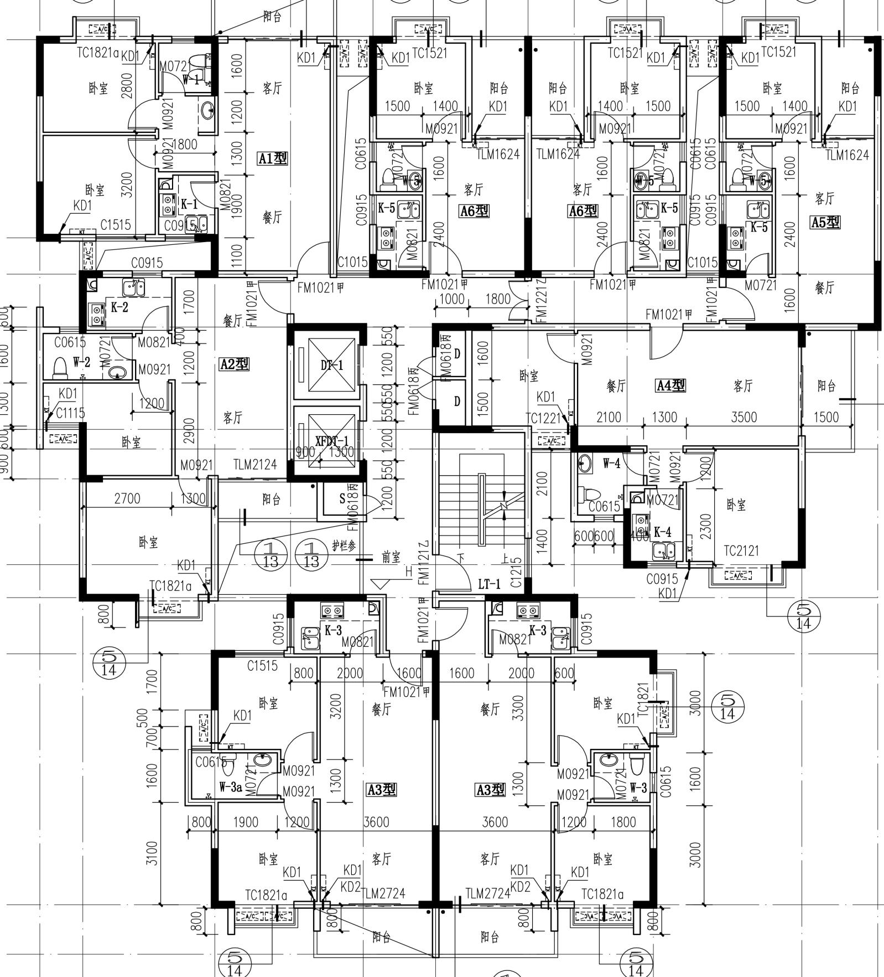

雅居苑教师公寓公租房项目A01户型
（建筑面积：76.9㎡；套内62.46㎡）

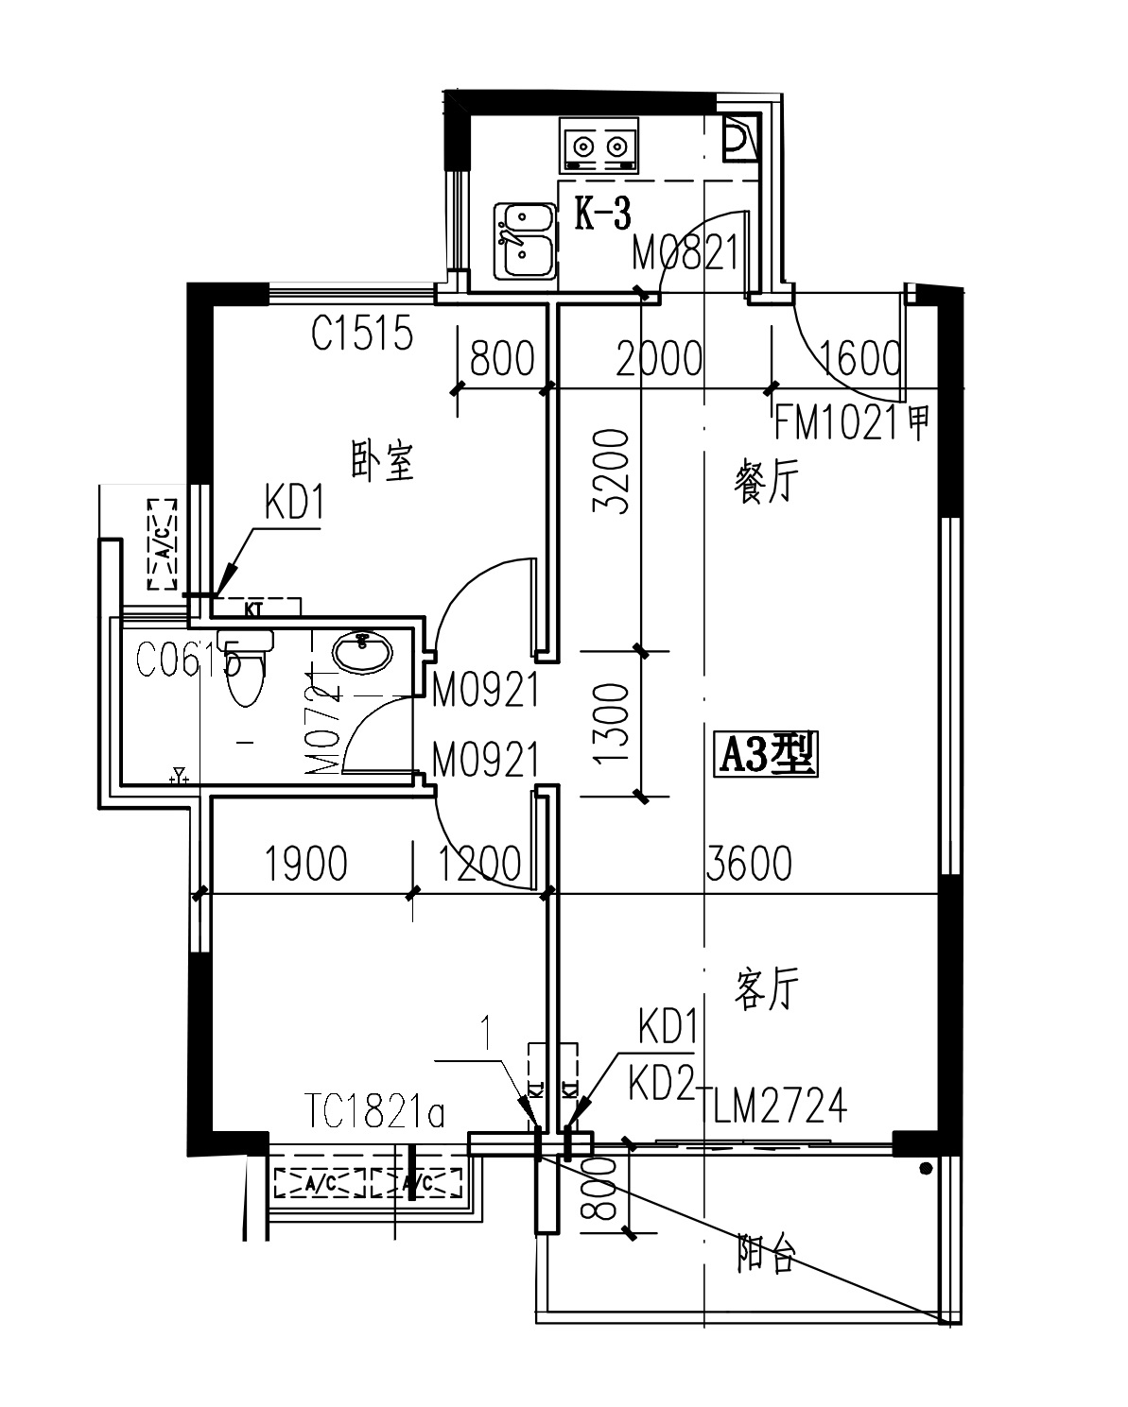
雅居苑教师公寓公租房项目A02户型
（建筑面积：73.97㎡；套内60.08㎡）
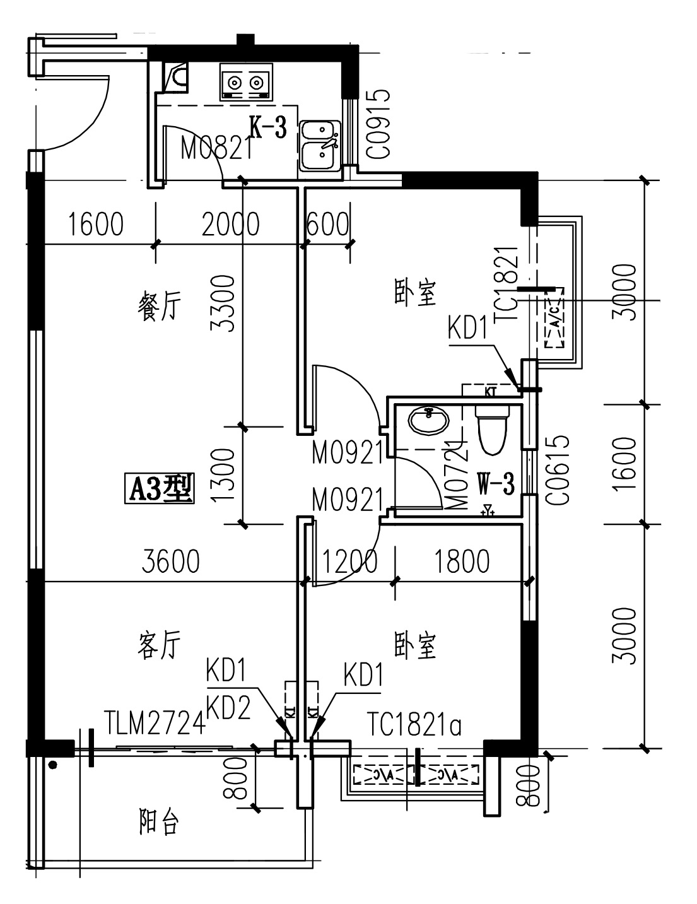
雅居苑教师公寓公租房项目A03户型
（建筑面积：72.68㎡；套内59.03㎡）
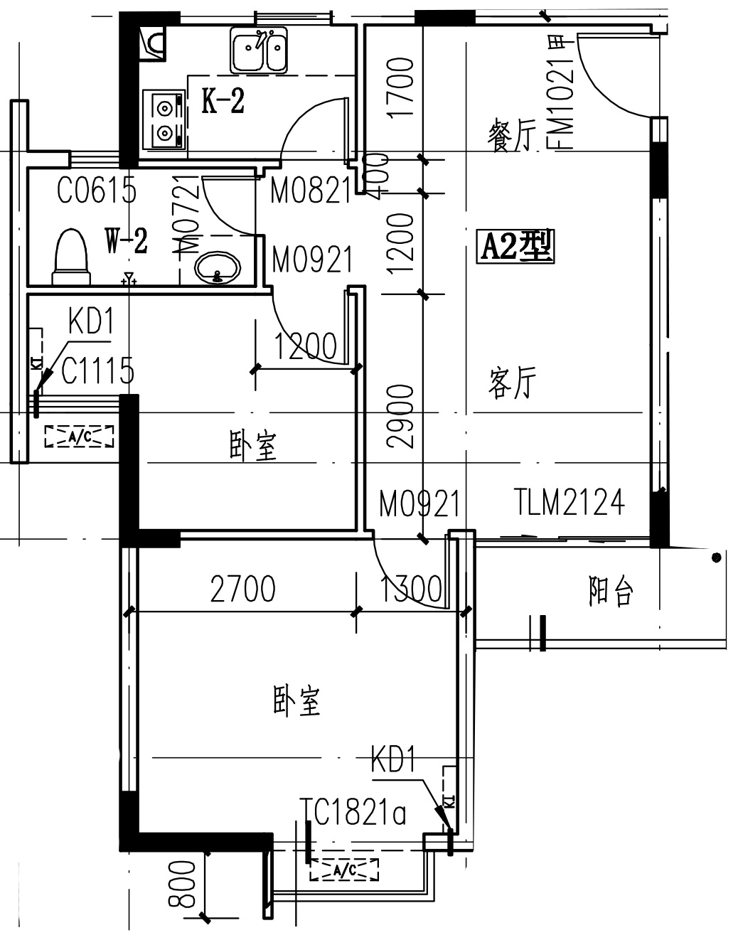

雅居苑教师公寓公租房项目A04户型
（建筑面积：74.14㎡；套内60.21㎡）
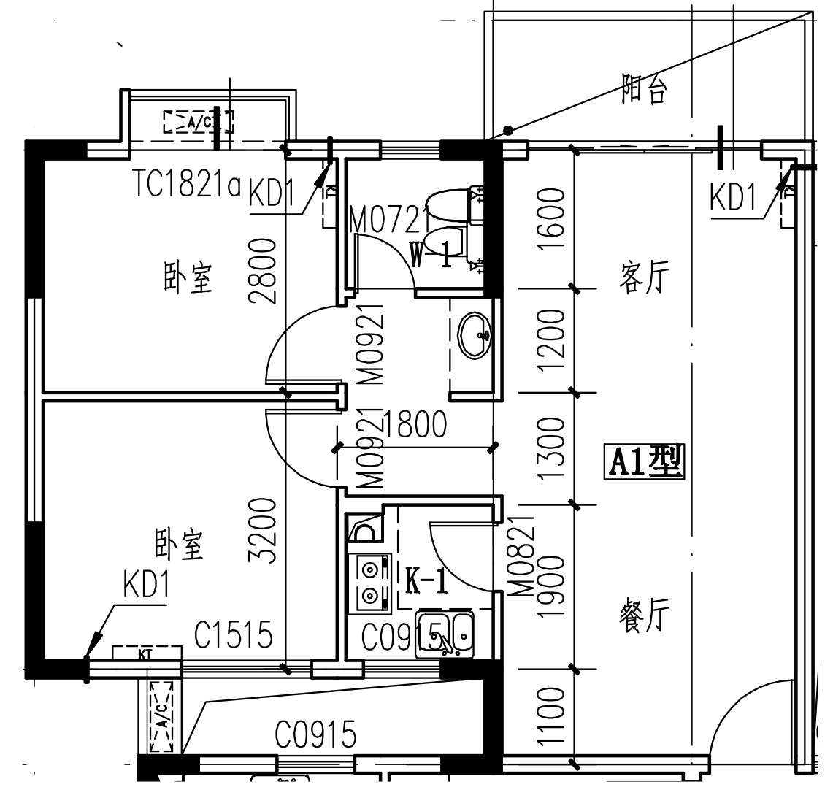
雅居苑教师公寓公租房项目A05户型
（建筑面积：37.58㎡；套内30.52㎡）
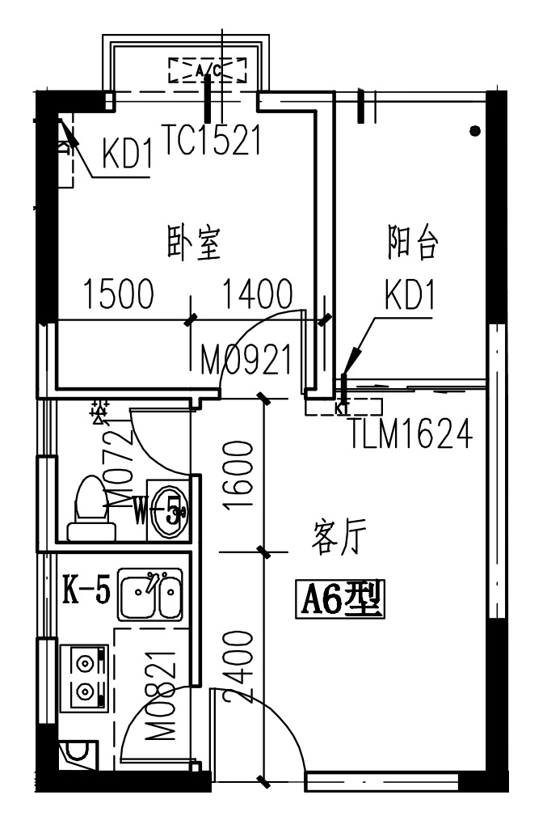
雅居苑教师公寓公租房项目A06户型
（建筑面积：37.58㎡；套内30.52㎡）
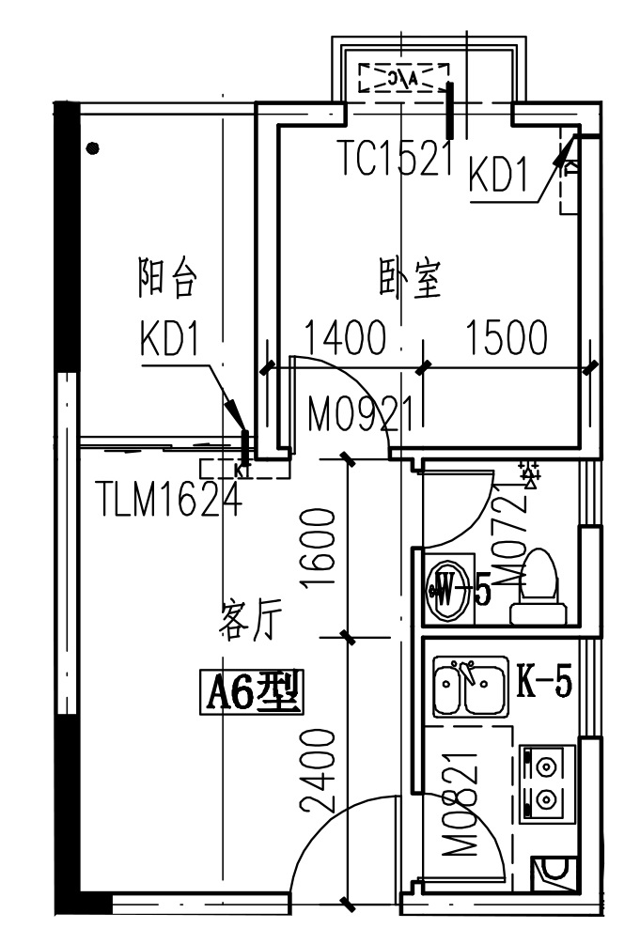
雅居苑教师公寓公租房项目A07户型
（建筑面积：75.08㎡；套内60.98㎡）

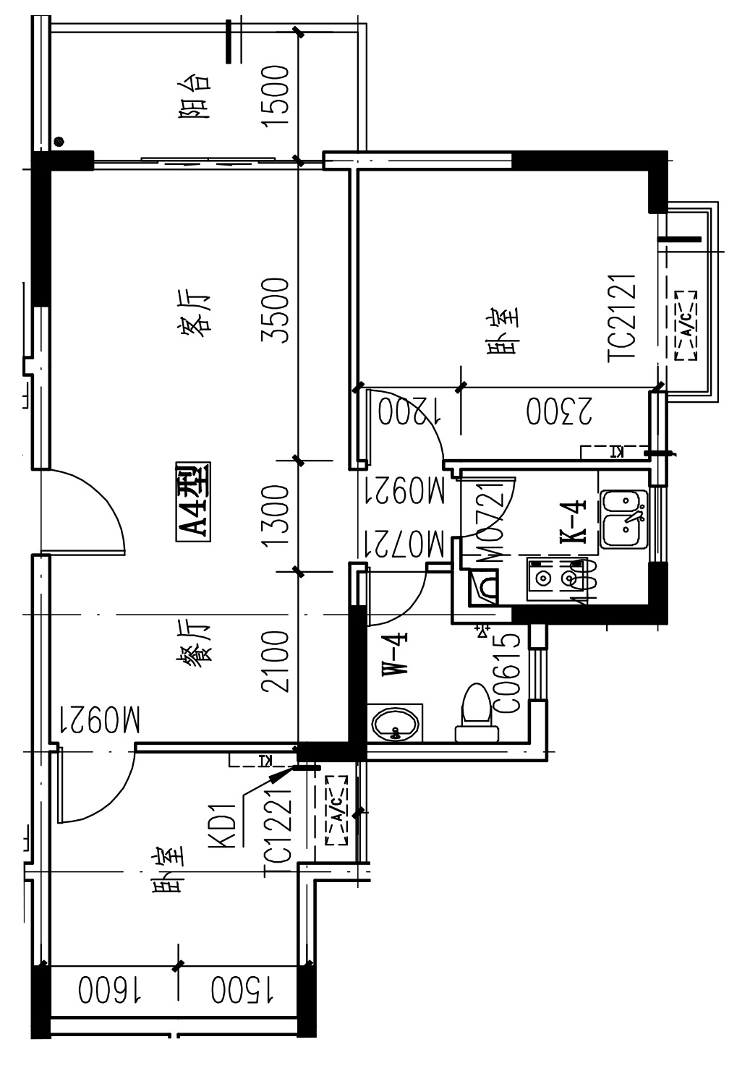
雅居苑教师公寓公租房项目A08户型
（建筑面积：47.02㎡；套内38.19㎡）
